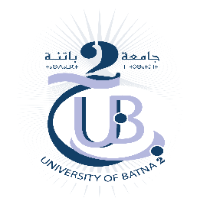
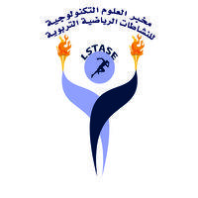

Mustafa Ben Boulaid University of Batna2

Institute of Sciences and Techniques of Physical and Sports Activities

Laboratory of Technological Sciences for Educational Sports Activities

Auras Journal of Sports Sciences

AURAS JOURNAL OF SPORTS SCIENCES
A peer-reviewed scientific journal published by the Laboratory of Technological Sciences for Educational Sports Activities.
ISSN : 2830-9987 e-ISSN : 2992-0760
Copyright Policy
The copyright and intellectual property rights of articles published in the Aurès Journal of Sports Sciences remain the exclusive property of their authors. Publication in the journal does not result in the transfer of these rights.
By submitting a manuscript for publication, the author(s) grant the journal the right of first publication, as well as the right to reproduce, publish, and disseminate the article in both print and electronic formats under its Open Access policy, in accordance with the Creative Commons Attribution 4.0 International (CC BY 4.0) license.
This license permits others to copy, distribute, share, reuse, adapt, and reproduce the content, including for commercial purposes, provided that appropriate credit is given to the original author(s), the journal, and the source of publication, and that any modifications made to the work are clearly indicated.
Authors retain their full moral rights, including the right to be identified as the authors of their work, as well as their intellectual property rights, in accordance with the licensing policy adopted by the journal.
By submitting a manuscript to the journal, the author(s) declare that.
- the manuscript is an original work authored by them and has not been previously published or submitted for publication elsewhere.
- all co-authors have reviewed and approved the final version of the manuscript and have agreed to its submission for publication.
- the manuscript does not infringe the copyright or intellectual property rights of any third party.
- all necessary permissions and approvals have been obtained for the use of copyrighted materials, data, photographs, figures, or any other protected content included in the manuscript, where applicable.
- they grant the journal the right of first publication under the terms of the Creative Commons Attribution 4.0 International (CC BY 4.0) license while retaining the intellectual property rights to their work.
- the author(s) bear full responsibility for the content of the manuscript, including the accuracy of the data, results, and opinions presented therein.
- any reuse of the article, in whole or in part, must comply with the terms of the (CC BY 4.0) license and include proper attribution to the author(s), the journal, and the original source of publication.
- the journal reserves the right to archive and disseminate published articles lectronically through the databases and digital repositories with which it collaborates, while fully respecting the authors' rights.

